Chapter 7, Solution 87.

Let i be the inductor current.

For t < 0, 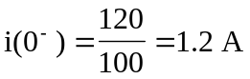

For t > 0, we have an RL circuit
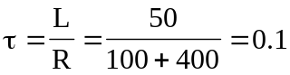, 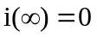
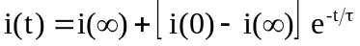
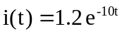

At t = 100 ms = 0.1 s,
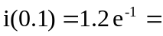 441mA
which is the same as the current through the resistor.

